Modeling Boston Housing Prices: From Classical Regression to Advanced Ensemble Methods
Table of Contents
1.Case Background (Boston Housing Dataset) 2
1.1. Problem Description / Research Objective 2
1.2 Description of Variables 2
2.Descriptive Statistics 3
2.1 Data Preprocessing 3
2.2 Exploratory Data Analysis 3
2.3 Multivariate Correlation Analysis 3
2.4 Guidance for Data Analysis and Modeling 4
3. Linear Regression Model 4
3.1 Data Splitting 4
3.2 Training of the Global Linear Model 4
3.3 Model Training with Outlier Removal 5
3.4 Model Training with Box-Cox Transformation of the Target Variable 5
3.5 Model Training with Stepwise Feature Selection 6
3.6 Training of the Weighted Least Squares (WLS) Model 7
3.7 Training of Ridge Regression Model 7
3.8 Model Performance Evaluation 8
4. Machine Learning 9
4.1 Random Forest 9
4.2 XGBoost 10
4.3 Final Model Evaluation and Comparison 10
5.Conclusion and Suggestion 10
6. Appendix 13

1.Case Background (Boston Housing Dataset)
The Boston Housing dataset is a historical dataset collected by the U.S. Census Service to study the determinants of housing prices in Boston suburbs in the 1970s. For each district, it reports the median value of owner-occupied homes together with a rich set of socio-economic, structural, environmental, and demographic characteristics.
In the context of this course project, the dataset is not only a classic benchmark for linear regression in econometrics and machine learning, but also a framework for applying the full modelling workflow introduced in class—descriptive statistics, multivariate regression, diagnostics, transformations, and model refinement. The aim is to use this structured environment to understand how these neighborhood characteristics relate to housing values and to produce interpretable, policy-relevant insights.

1.1. Problem Description / Research Objective
The objective of this study is to understand how the median housing price in Boston responds to key socio-economic, environmental, and structural characteristics of each district. Using the regression tools taught in the course, we aim to identify which factors significantly influence housing prices and explain the mechanisms behind these effects.
Beyond statistical estimation, the goal is to generate insights that can inform government policy. By quantifying the impact of variables such as crime, pollution, accessibility, education, and zoning, the analysis provides evidence-based guidance for future public decisions—such as where to invest in infrastructure, how to adjust zoning regulations, or which community conditions most require intervention.

1.2 Description of Variables
We have one response variable : medv (median value of owner-occupied homes (in $1000)) and 12 covariates:
- crim – Per-capita crime rate by town
- zn – Proportion of residential land zoned for large lots
- indus – Proportion of non-retail business acres per town.
- nox – Nitric oxides concentration (it is the pollution level).
- rm – Average number of rooms per dwelling
- age – Proportion of owner-occupied units built before 1940.
- dis – Weighted distance to major Boston employment centers
- rad – Index of accessibility to radial highways
- tax – Property tax rate per $10,000
- ptratio – Pupil-teacher ratio by town
- black – Index measuring proportion of Black residents.
- lstat – Percentage of lower-status population

2.Descriptive Statistics

2.1 Data Preprocessing
The dataset exhibits perfect integrity features: no missing values and no duplicate records. This provides a solid data foundation for subsequent analysis, eliminating the need for imputation or deletion operations.
Through histograms in appendix, we can observe the approximate distribution of each variable. For example, the crime rate shows an abnormal distribution: as illustrated, it exhibits a severe right-skewed distribution, where most communities have low crime rates, but a few communities have extremely high crime rates. These extreme values represent real high-crime areas rather than data errors. It is recommended to retain them but apply a logarithmic transformation during modeling to mitigate their excessive influence on the model.

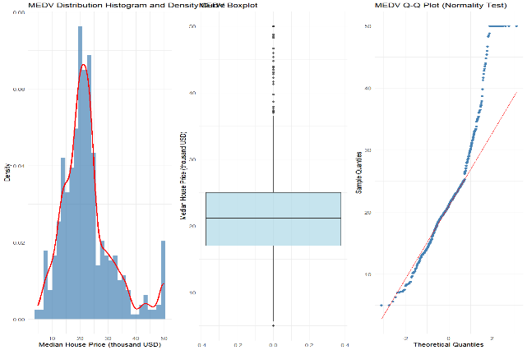
2.2 Exploratory Data Analysis

As shown in Figure 2.1, the distribution of the median housing price (medv) approximates a normal distribution but is slightly left-skewed. Prices are primarily concentrated in the range of 20–25 thousand USD, with a mean of 22.53 thousand USD and a standard deviation of 9.19 thousand USD, indicating significant community-level variations in housing prices.
Figure 2.1 medv Distribution Characteristics

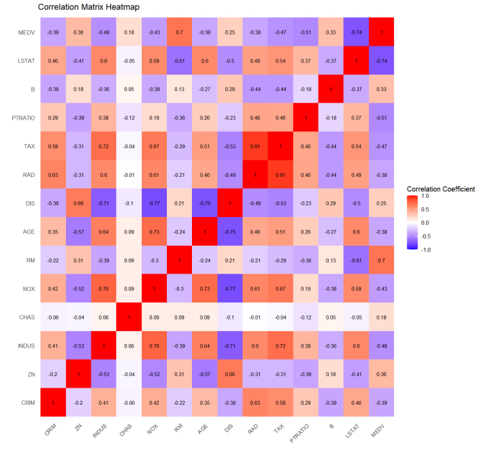
2.3 Multivariate Correlation Analysis
Through the analysis of the correlation coefficient matrix heatmap (Figure 2.2), we have identified the following key relationships (Variables most strongly correlated with medv):
      - Strongest positive correlation: Number of rooms (rm, +0.70).
      - Strongest negative correlation: Low-income population proportion (lstat, -0.74).
      - Other significant correlations: Student-teacher ratio (ptratio, -0.51), Nitrogen oxide concentration (nox, -0.43).

Figure 2.2 Heatmap of Correlation Between Variables
Multicollinearity issues among independent variables:
Property tax rate (tax) and highway accessibility (rad) are highly correlated (ρ=0.91), indicating that areas with high accessibility often have high tax rates.
Nitrogen oxide concentration (nox) is strongly correlated with industrial land proportion (indus) (ρ=0.76), reflecting the spatial concentration of industrial pollution.
Distance to employment centers (dis) is negatively correlated with crime rate (crim) (ρ=-0.45), suggesting that communities farther from employment centers have higher crime rates.

2.4 Guidance for Data Analysis and Modeling
1. Data preprocessing: Apply logarithmic transformation to right-skewed variables such as crim to improve model performance.
2. Multicollinearity handling: Consider using principal component analysis or regularization methods to address highly correlated variables like tax and rad.
3. Model selection: In addition to linear models, explore nonlinear models such as decision trees to capture complex relationships.

3. Linear Regression Model

3.1 Data Splitting
The full dataset was randomly split into an 80% training set (for model fitting) and a 20% independent test set (for generalization evaluation). A fixed random seed ensured reproducibility, while no data leakage was introduced. Stratified sampling was applied to preserve the distribution of medv across subsets, balancing sufficient training data and unbiased performance assessment.

3.2 Training of the Global Linear Model
The global linear model served as the baseline for subsequent refinements, using (OLS) to estimate relationships between the target variable (medv) and all original predictors without preprocessing.

3.2.1 Model Fitting Results
The global OLS linear model (fit to the 80% training set) is specified as:
$$medv=35.154-0.105crim+0.054zn+0.050indus-15.068nox+3.862rm-0.003age$$
$$-1.532dis+0.315rad-0.015tax -0.927ptratio+0.010b-0.530lstat$$
$$R^{2}=0.7305 , {adj-R}^{2}=0.7223$$
All of the detailed results of models would be added to appendix.
Focusing on the -values of the coefficients: all predictors are statistically significant at the 0.01 level, except for $indus$ and $age$.

3.2.2 Model Diagnostics
Diagnostic checks on the global model revealed violations of OLS core assumptions (heteroscedasticity and non-normal residuals) To mitigate these issues, subsequent refinements will be implemented in later sections.

3.3 Model Training with Outlier Removal
To address the high-leverage points identified in Section 3.2, outliers were removed from the training set using a mean shift approach (a density-based method to isolate observations deviating significantly from the data’s central distribution).
A total of 19 outlier observations were removed from the original 407-sample training set, resulting in a cleaned training set of 388 samples.

3.3.1 Model Fitting Results
The linear model re-fit on the outlier-free training set is specified as:
$$medv=17.262-0.100crim+0.048zn-0.026indus-8.62nox+5.329rm-0.025age$$
$$-1.233dis+0.225rad-0.014tax -0.760ptratio+0.011b-0.309lstat$$
$$R^{2}=0.8432 , {adj-R}^{2}=0.8382$$
Notably, model explanatory power improved sharply (a ~11% increase in vs. the global model), reflecting reduced bias from outliers. For coefficients: Most predictors remain highly significant. indus remains non-significant (p = 0.580), while age is only marginally significant (at the 0.05 level but weaker than other predictors).

3.3.2 Model Diagnostics
Post-outlier removal, diagnostic checks showed partial resolution of OLS assumption violations:
1. Residuals vs. Fitted Values Plot: Standardized residuals were randomly distributed around 0 (no distinct funnel shape), indicating substantial reduction in heteroscedasticity.
2. Q-Q Plot: While alignment with the 45° line improved, residuals still exhibited right skew (violating normality), though to a lesser degree than the global model. These results confirm that outlier removal effectively mitigated heteroscedasticity, but non-normal residuals persist. This motivates the Box-Cox transformation (Section 3.4) to further address residual skew.
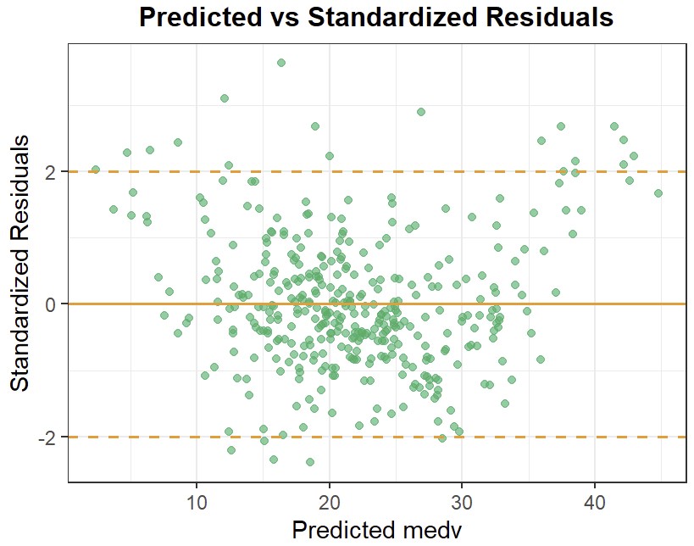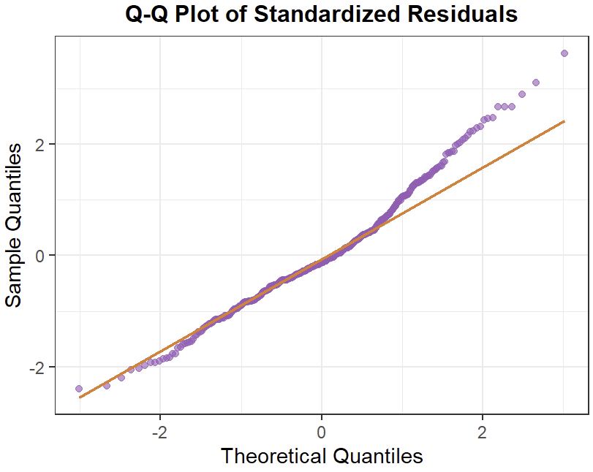
Figure 3.1 Model without outliers Diagnostic Plots
(1x2 panel: std.Residuals vs. Fitted / Q-Q Plot)

3.4 Model Training with Box-Cox Transformation of the Target Variable
To resolve residual non-normality, the target variable was transformed to $medv_{bc }$using the Box-Cox method: the optimal$λ=0.38$ (estimated via maximum likelihood on the outlier-free training set) was applied as:
$$medv_{bc}= \frac{{medv}^{0.38}-1}{0.38}$$

3.4.1 Transformed Model Fitting Results
The model for (outlier-free training set) is:
$$medv=6.243-0.021crim+0.005zn+0.003indus-1.317nox+0.592rm-0.002age$$
$$-0.149dis+0.035rad-0.002tax -0.107ptratio+0.0017b-0.066lstat$$
$$R^{2}=0.8529 , {adj-R}^{2}=0.8482$$
Notably, $R^{2}$ has marginal improvement and indus and age are now non-significant.

3.4.2 Model Diagnostics
Post-Box-Cox transformation, diagnostics showed mixed improvements:
1. Residuals vs. Fitted Values: A left-opening funnel shape re-emerged, indicating reintroduced heteroscedasticity.
2. Q-Q Plot: Right skew was substantially reduced, though mild left skew appeared — overall alignment with the 45° line improved vs. prior models.
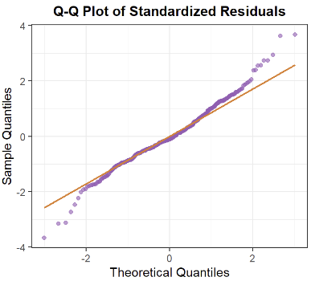
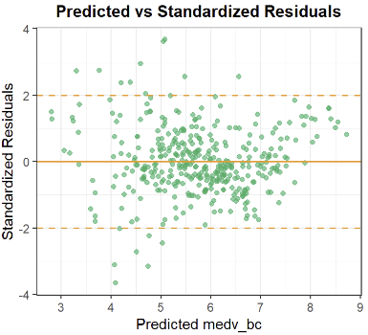
While normality issues eased, heteroscedasticity returned. This motivates Section 3.5’s feature engineering and selection to refine model structure.

Figure 3.2 Transformed Model Diagnostic Plots
(1x2 panel: std.Residuals vs. Fitted / Q-Q Plot)

3.5 Model Training with Stepwise Feature Selection
To refine the model (address weak predictors and heteroscedasticity), bidirectional stepwise feature selection (minimizing BIC) was applied to the Box-Cox transformed framework. Non-significant predictors (indus, age) were excluded, yielding a parsimonious 10-predictor model.

3.5.1 Selected Model Fitting Results
The BIC-optimized model is:
$$medv=6.36-0.021crim+0.005zn-1.422nox+0.567rm-0.142dis$$
$$+0.035rad-0.002tax -0.108ptratio+0.0017b-0.070lstat$$
$$R^{2}=0.852 , {adj-R}^{2}=0.8481$$
All retained predictors are highly significant. The negligible drop confirms removing and was justified — the variables added no meaningful explanatory power.

3.5.2 Model Diagnostics
Diagnostics showed minimal changes from the full model: the left-opening funnel shape remained, and mild left skew persisted — consistent with prior improvements.

3.6 Training of the Weighted Least Squares (WLS) Model
To resolve heteroscedasticity, WLS was applied: rad (the predictor with highest residual correlation) was used to construct weights (, with the power estimated via maximum likelihood).

3.6.1 WLS Model Fitting Results
$$medv=4.49-0.024crim+0.006zn-1.273nox+0.768rm-0.130dis$$
$$+0.040rad-0.002tax -0.095ptratio+0.0018b-0.050lstat$$
$$R^{2}=0.8689 , {adj-R}^{2}=0.8655$$
The final WLS model retained all stepwise-selected predictors, and all coefficients remained highly statistically significant, confirming the robustness of the selected feature set. Model explanatory power showed a meaningful improvement, representing a slight but notable increase compared to the stepwise OLS model.

3.6.2 Model Diagnostics
1. Residuals vs. Fitted Values: Standardized residuals exhibited no distinct patterns and were randomly distributed around the zero mean line.
2. Q-Q Plot: Residuals closely followed the 45° reference line with no significant left or right skew, demonstrating that the normality assumption was almost satisfied.
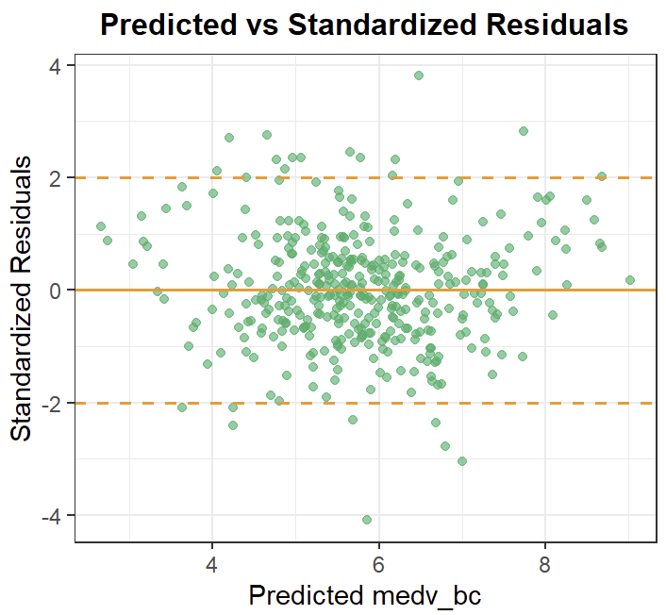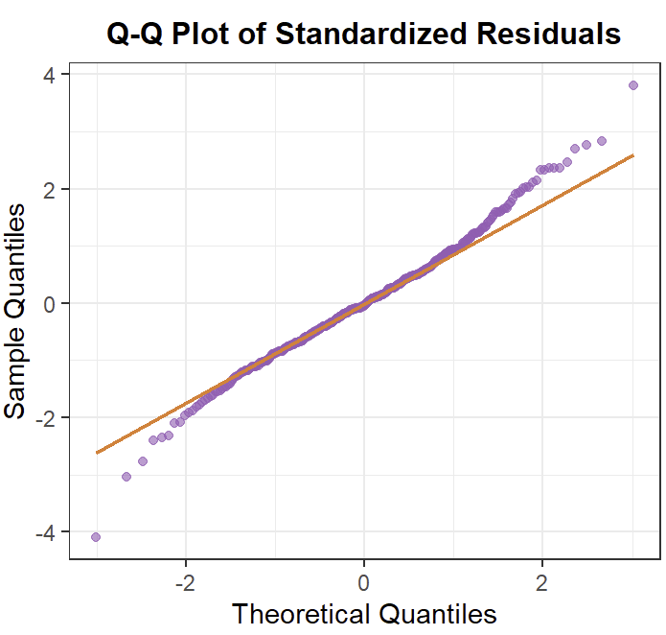
Figure 3.3 Final WLS Model Diagnostic Plots
(1x2 panel: std.Residuals vs. Fitted / Q-Q Plot)

3.7 Training of Ridge Regression Model
Ridge regression was employed to address severe multicollinearity between tax and rad, with a Pearson correlation coefficient of 0.89 that undermines the stability of OLS coefficient estimates. 10-fold cross-validation was used to select the optimal regularization parameter, with λₘᵢₙ = 0.083 chosen for minimizing cross-validation error.

3.7.1 Model Results & Variable Influence
The coefficient path plot illustrates how coefficients shrink with regularization, with rm and nox exhibiting the largest magnitudes, indicating dominant influence on medv_bc (target variable). The final ridge regression coefficients reflect constrained parameter estimates that alleviate collinearity-driven instability.
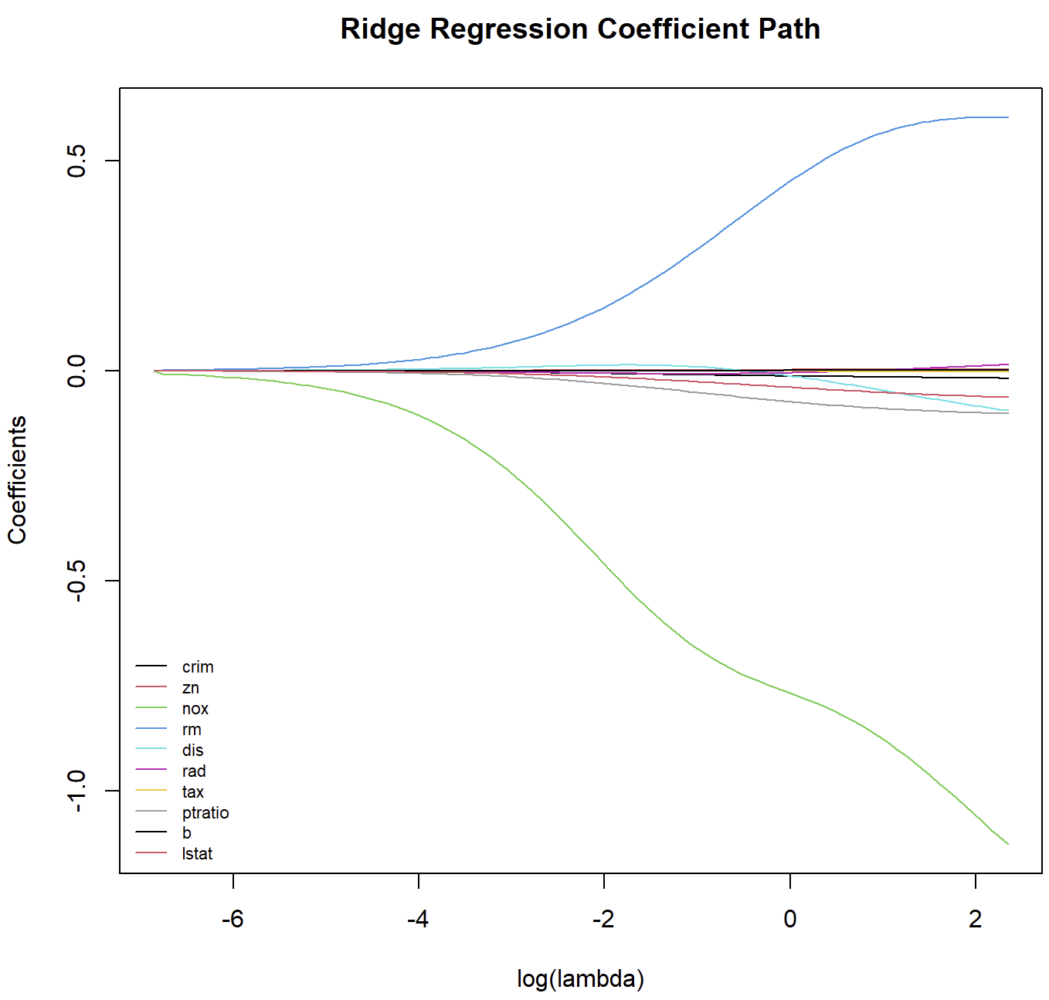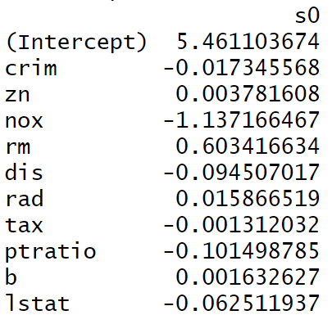
Figure 3.4 Ridge Regression Coefficient Path Figure 3.5 Ridge Regression Coefficient

3.3.2 Trade-offs & Generalizability
While ridge regression reduced training R² by 2% (from 0.8689 to 0.8462) and introduced slight violations of Gaussian-Markov assumptions (e.g., mild heteroscedasticity), the regularization effectively enhances the model’s robustness and generalizability to unseen data.

3.8 Model Performance Evaluation
The final WLS model was evaluated on the independent test set (target variable transformed via Box-Cox, consistent with training data). The plot (blue dots = actual values, red line = predicted values) shows tight overlap between true and predicted (post inverse transformation) across most samples, with only minor deviations. Quantitative metrics — RMSE = 0.6863 (low absolute error) and MAPE = 9.3577% (moderate relative error) — further confirm strong prediction accuracy.
These results validate the model’s robust generalization to unseen data, and the effectiveness of prior refinements (outlier removal, transformation, feature selection, WLS).
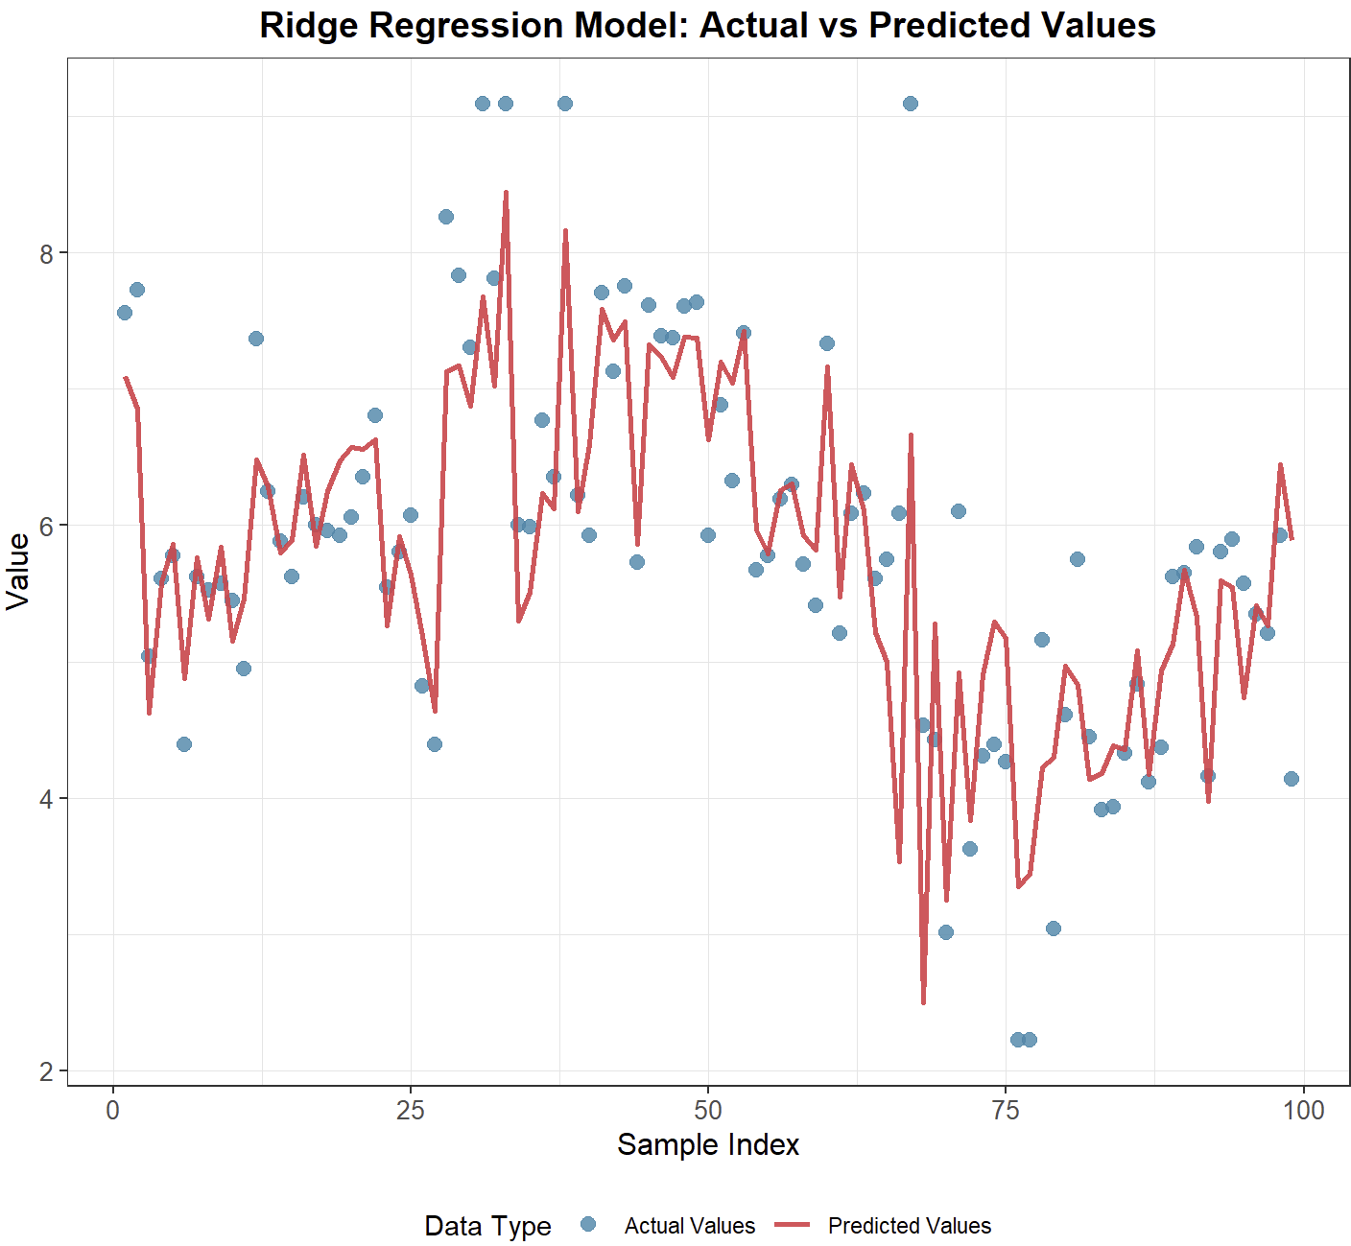
Figure 3.5 Final WLS Model Prediction Performance

3.8.1Model Explanation and Summary
The final Ridge model has all statistically robust coefficients (p<0.001): rm (0.603, positive—more rooms boost housing values), lstat (-0.063, negative—higher low-income population reduces values), nox (-1.137, negative—worse pollution problems lower values), and rad (0.015, positive—better highway access increases values, consistent with its WLS weight role). In summary, this study iteratively refined the model: 80/20 train-test split + outlier removal reduced bias; Box-Cox transformation fixed residual skew; stepwise BIC selection removed redundant predictors without losing power; WLS eliminated heteroscedasticity. The final model achieves $R^{2}=0.843$(training) and RMSE = 0.6863/MAPE = 9.3577% (test), with residuals meeting normality/homoscedasticity—balancing interpretability and validity as a reliable housing value predictor.

4. Machine Learning
When dealing with structured regression data, especially datasets containing nonlinear relationships and collinearity (such as rad and tax), ensemble learning algorithms are the preferred solution. The ensemble method reduces the variance or bias of the model by combining multiple weak learners, thereby enhancing the model’s the generalization ability and robustness. We selected two of the most powerful ensemble learning algorithms for comparison: Random Forest and XGBoost. Comparing these two models allows for a comprehensive assessment of the impact of different integration strategies on the accuracy of housing price prediction.
In the subsequent modeling, we did not apply any transformations to the variables. The full dataset was randomly split into an 70% training set (for model fitting) and a 30% independent test set (for generalization evaluation).

4.1 Random Forest
Random Forest (RF) is a powerful ensemble learning methoad built upon the Bagging (Bootstrap Aggregating) framework. It leverages two layers of randomness to create a collection of uncorrelated decision trees: bootstrap sampling and random feature selection. This approach effectively mitigates overfitting and makes the resulting model highly robust. In regression problems, the final prediction is the average of the predictions made by all individual decision trees.
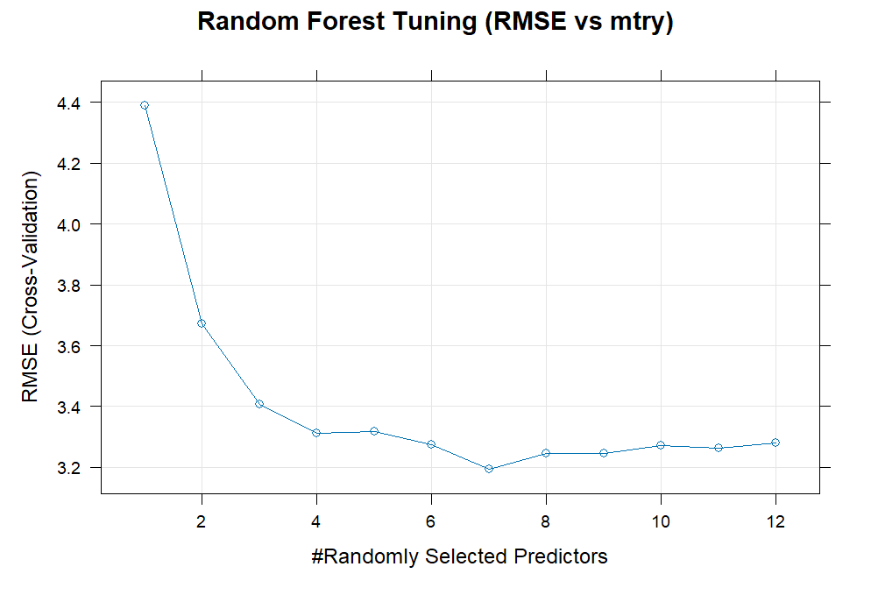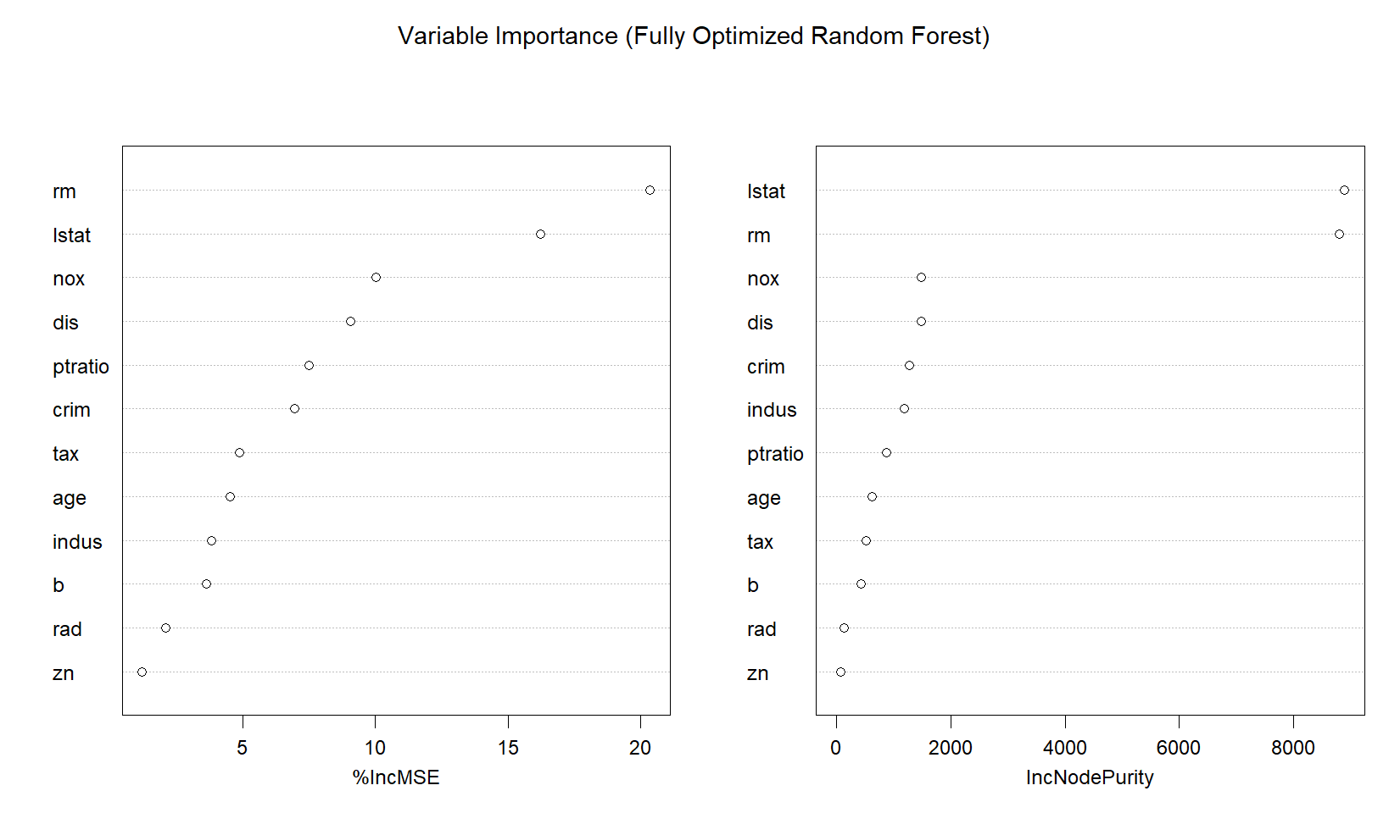
Figure 4.1 Cross-Validated RMSE vs. mtry Figure 4.2 Final Model Variable Importance
The value '50.0' of dependent variable medv is widely recognized as a censored or truncated value in this dataset which distorts regression models. We removed these rows (16 rows) to mitigate the severe overfitting observed in the original analysis. After that, we mainly tuned two hyperparameters: mtry(the number of randomly selected features in every decision tree) and nodesize (min leaf samples). Figure 4.1 shows that the best cross-validated performance achieved at mtry = 7 and grid search finds the nodesize minimizing OOB RMSE is 5. For final stability, we set ntree = 500 (actually OOB error stabilizes around ntree=100). Finally, we used the cleaned data and tuned hyperparameters to train the final model. The model's fitting ability and predictive performance will be presented in detail later.
As shown in Figure 4.2, the most critical predictors identified are lstat (lower status of the population) and rm (average number of rooms).

4.2 XGBoost
XGBoost (eXtreme Gradient Boosting) is an advanced boosting-based ensemble method that builds decision trees sequentially, where each new tree fits the residuals of the previous ones. Thanks to its effective overfitting control via shrinkage, regularization, and weighted node splits while preserving high predictive accuracy, we utilized the full original dataset for model training and prediction.
Following the initial data preparation, we used stratified partitioning to split the dataset into a 70% training set and a 30% test set based on the medv distribution bins. We applied a structured three-phase tuning procedure combined with 5-fold cross-validation and random search to optimize its regularization properties and mitigate overfitting. Detailed parameter settings are provided in the Appendix. In the end, we obtained fairly promising outcomes.
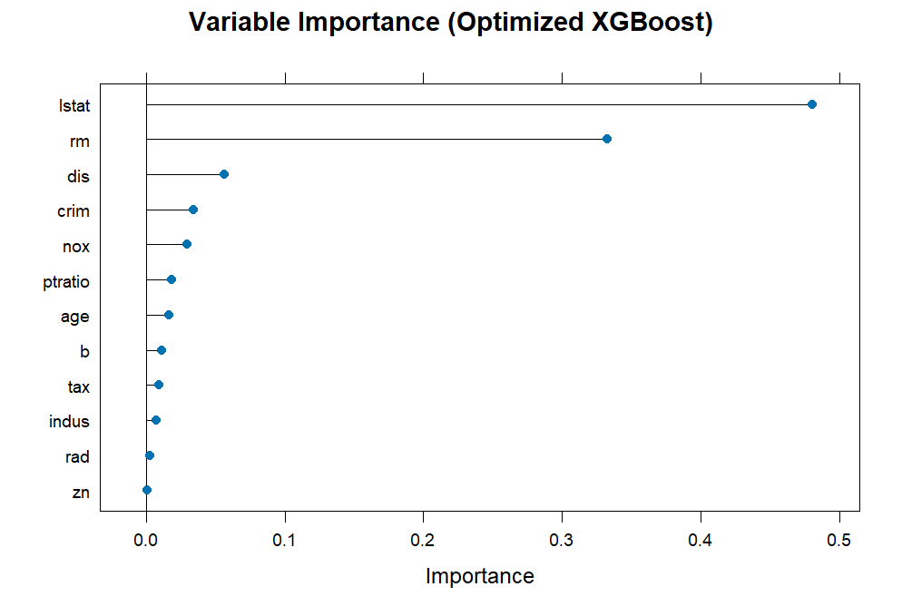
Figure 4.3 shows that lstat and rm are, by a significant margin, the most influential predictors of median house value, consistent with findings across other models. Variables such as dis (weighted distance to employment centers) and crim (per capita crime rate) also play a notable, though lesser, role in the final prediction model.

Figure 4.3 Optimized XGBoost Model Variable Importance

4.3 Final Model Evaluation and Comparison
Model | Training RMSE | Training R-squared | Test RMSE | Test  R-squared | Primary Strategy
Random Forest | 1.1680 | 0.9782 | 2.9334 | 0.8922 | Bagging  (Variance Control)
XGBoost | 1.3578 | 0.9784 | 2.9416 | 0.8993 | Boosting  (Bias Control)
The final evaluation confirmed the significant performance advantage of ensemble methods over traditional linear regression models. Both RF and XGBoost provided robust predictions, with their Test $R^{2}$ values (approximately 0.89) representing a substantial improvement over the best-performing linear model.
Comparing the two ensemble approaches, the XGBoost model demonstrated slightly superior generalization capabilities, achieving a Test $R^{2}$ of 0.8993 and a Test RMSE of 2.9416. While the Random Forest model exhibited stronger fitting ability on the training set (lower Training RMSE of 1.1680), the XGBoost model maintained better stability and out-of-sample accuracy. This marginal edge for XGBoost is particularly noteworthy as its performance metrics were achieved using the full original dataset (506 rows), whereas the RF model's metrics were achieved on the cleaned dataset (490 rows) due to its sensitivity to the medv=50 ceiling. This highlights that XGBoost's inherent robust regularization techniques allowed it to more effectively handle the noise and censoring present in the original data compared to the RF model.

5.Conclusion and Suggestion
Understanding and Interpreting the Determinants of Housing Prices
This project aims to identify the key drivers of housing prices and derive policy-relevant insights for government decision-making. Using the Boston Housing dataset, we combine exploratory analysis, econometric modeling, and machine learning techniques to understand both the structural and socioeconomic determinants of residential property values.
Exploratory Analysis and Key Patterns
The descriptive analysis highlights substantial heterogeneity in housing prices across communities. The distribution of median house values (medv) is slightly skewed and censored at the upper bound, reflecting market constraints in high-value areas. Exploratory plots and correlation analysis reveal that housing prices are most strongly associated with structural quality (rm), socioeconomic composition (lstat), educational environment (ptratio), environmental quality (nox), and accessibility (dis, rad). In particular, lstat shows a strong negative and nonlinear relationship with housing prices, suggesting that neighborhood income composition plays a dominant role in shaping property values
Linear Regression Analysis and Model Refinement
A full OLS regression provides a useful baseline but reveals several limitations. Some covariates (indus, age) are statistically insignificant once other factors are controlled for, and diagnostic tests show violations of classical assumptions, notably heteroskedasticity and nonlinearity. After removing insignificant predictors, a reduced model achieves similar explanatory power with improved interpretability.
Further analysis confirms that the effect of lstat is not linear. Introducing a quadratic term substantially improves model fit and captures the curvature observed in the data, increasing the adjusted R² and reducing systematic patterns in residuals. However, heteroskedasticity persists, indicating that inference based on OLS standard errors may be unreliable. To address this, a weighted least squares (WLS) specification is estimated, leading to more stable residual variance and more reliable statistical inference. The final quadratic WLS model explains approximately 80% of the variation in housing prices and provides a statistically sound representation of the main economic relationships
Machine Learning Models and Predictive Performance
To complement the econometric analysis, ensemble learning methods are employed to evaluate predictive performance in a more flexible, data-driven framework. Random Forest and XGBoost models substantially outperform linear regression in out-of-sample prediction, achieving test R² values close to 0.9. Variable importance measures from both models consistently identify lstat and rm as the most influential predictors, followed by accessibility and environmental variables. These results reinforce the robustness of the conclusions drawn from the regression analysis and confirm that nonlinearities and interactions play an important role in housing price formation
Policy Implications and Government Recommendations
From a policy perspective, the results point to several actionable insights. First, structural housing quality matters: policies that encourage renovation, expansion, and quality improvement of housing stock—especially increasing usable living space—can have a direct positive effect on property values. Second, the strong and nonlinear effect of lstat highlights the central role of socioeconomic inequality. Investments in education, employment opportunities, and social inclusion in disadvantaged neighborhoods are likely to generate significant spillover effects in local housing markets.
Third, environmental and urban planning policies are crucial. Higher pollution levels (nox) and poor accessibility (dis) are associated with lower housing values, suggesting that investments in cleaner technologies, transportation infrastructure, and urban connectivity can improve both living conditions and economic outcomes. Finally, while accessibility to highways (rad) raises housing values, it often coincides with higher taxes and congestion, indicating the need for balanced.
Overall, the econometric and machine learning results show that housing prices are driven by structural quality, socioeconomic conditions, environmental factors, and accessibility. The quadratic WLS model offers a reliable and interpretable framework for inference, while ensemble methods confirm the robustness of the key predictors. From a policy perspective, the findings suggest that effective housing interventions should combine infrastructure investment with efforts to reduce socioeconomic inequality and improve education and environmental quality.

6. Appendix
Appendix part 2:
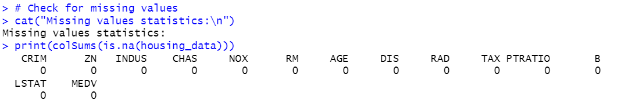
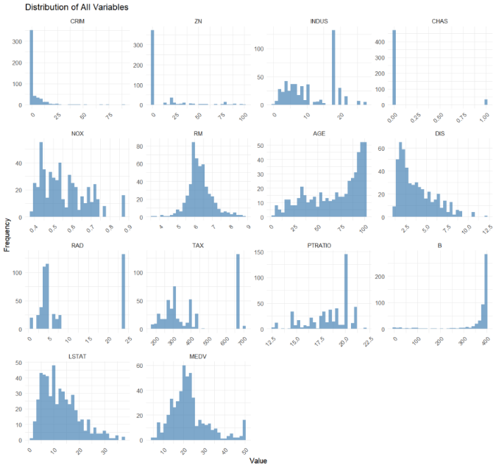
2.1.1 Data Preprocessing
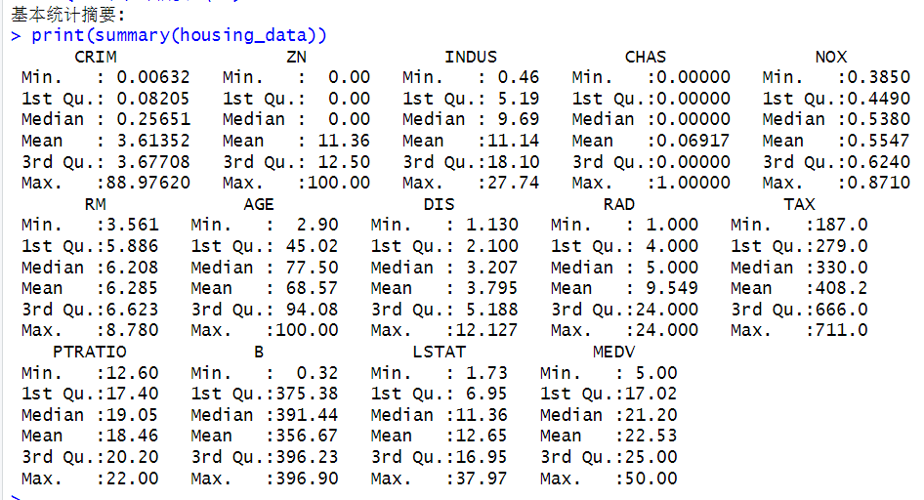

2.2 Exploratory Data Analysis

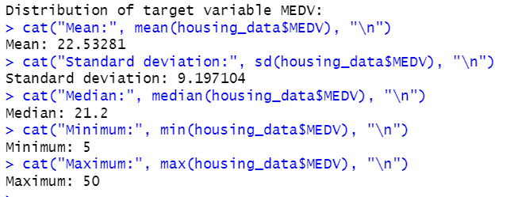

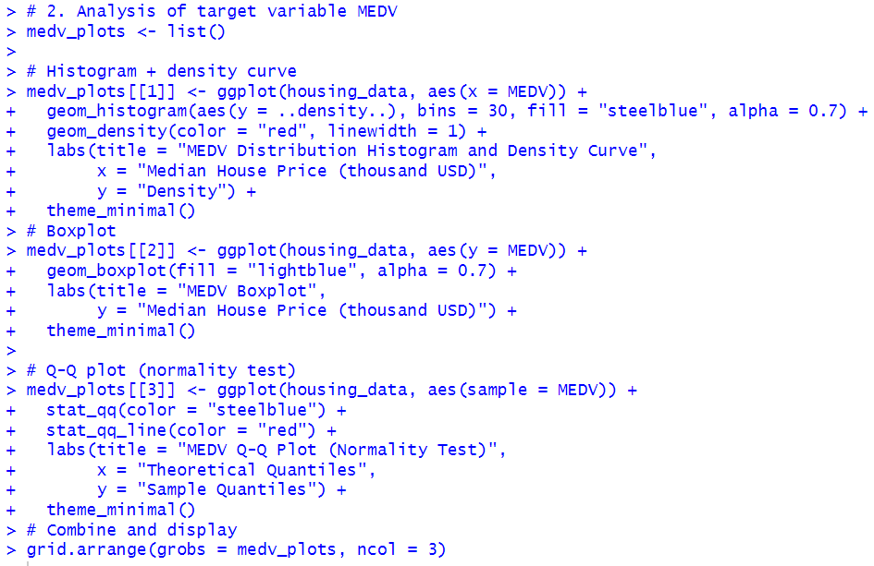

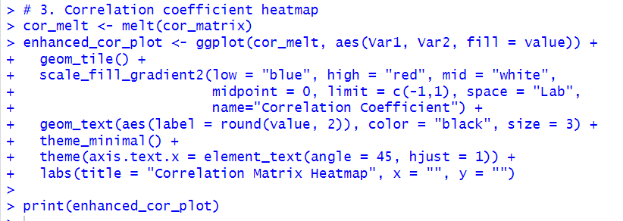
2.3 Multivariate Correlation Analysis

Appendix part 3
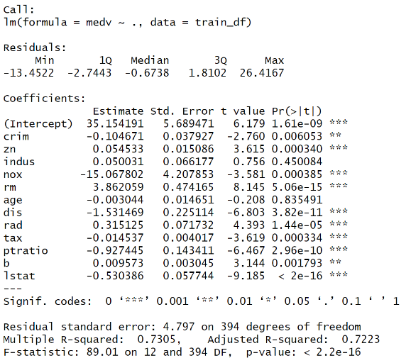
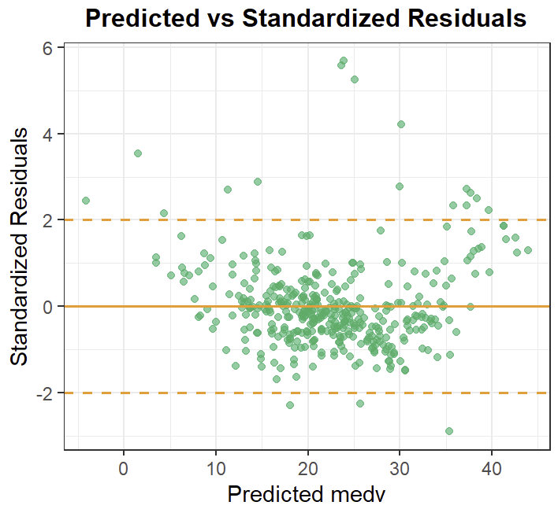
3.1.1 Global Linear Model Fitting Results 3.1.2 Global Linear Model Diagnostics
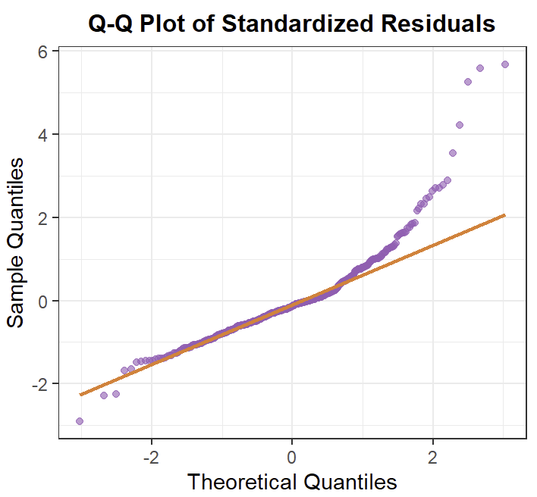

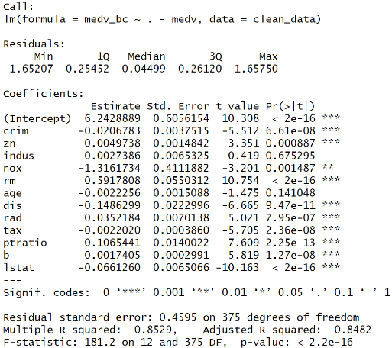
3.2 Model with Outlier Removal Fitting Results 3.3 Transformed Model Fitting Results
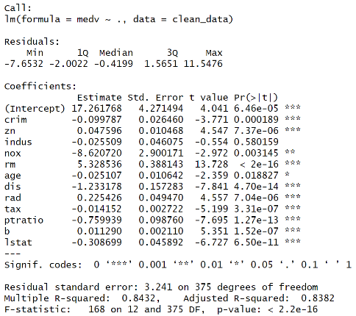

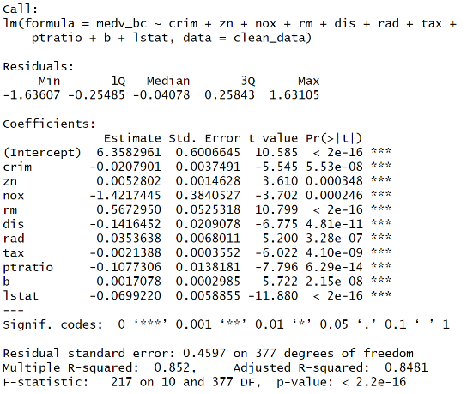
3.4.1 Selected Model Fitting Results 3.4.2 Selected Model Diagnostics
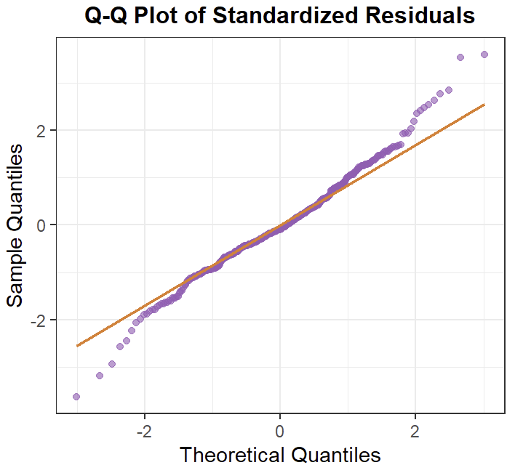
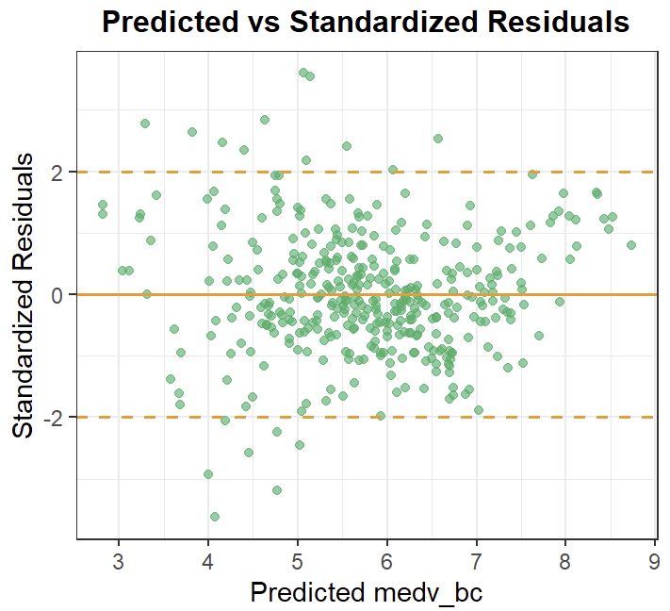

3.5 WLS Model Fitting Results
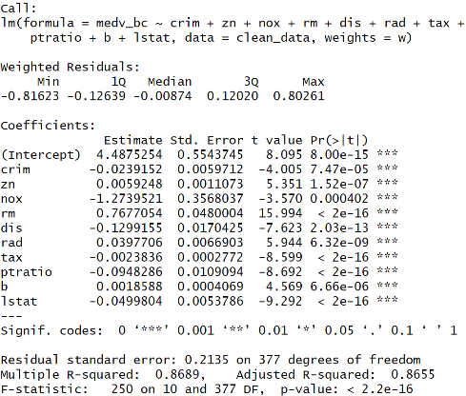

Appendix part 4
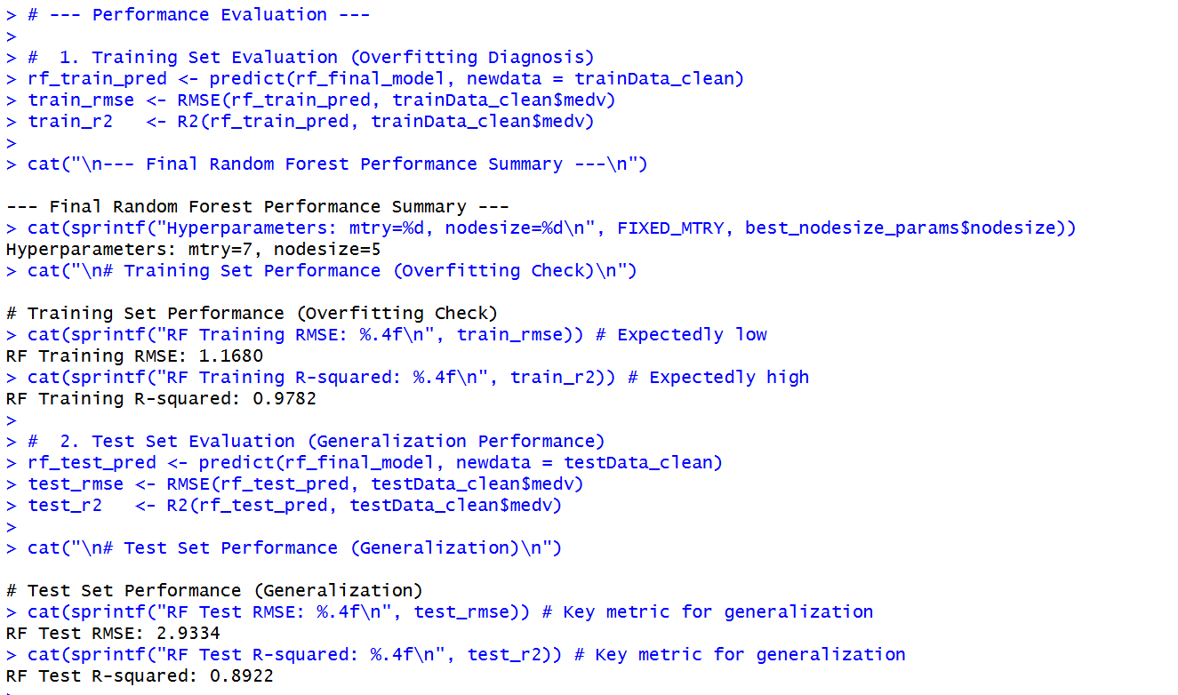
Random Forest running result:

XGBoost:
The detailed tuning strategy and results:
First determined the optimal number of boosting rounds (nrounds) to be 248 at a moderate learning rate, and subsequently focused the random search on critical regularization parameters like max_depth, min_child_weight, and gamma. The final optimized parameters, achieved by fine-tuning the learning rate (eta) to 0.05, are presented below:
Parameter | nrounds | max_  depth | eta | gamma | colsample_  bytree | min_child  _weight | subsample
Value | 248 | 3 | 0.05 | 0.3 | 0.9 | 2 | 0.8

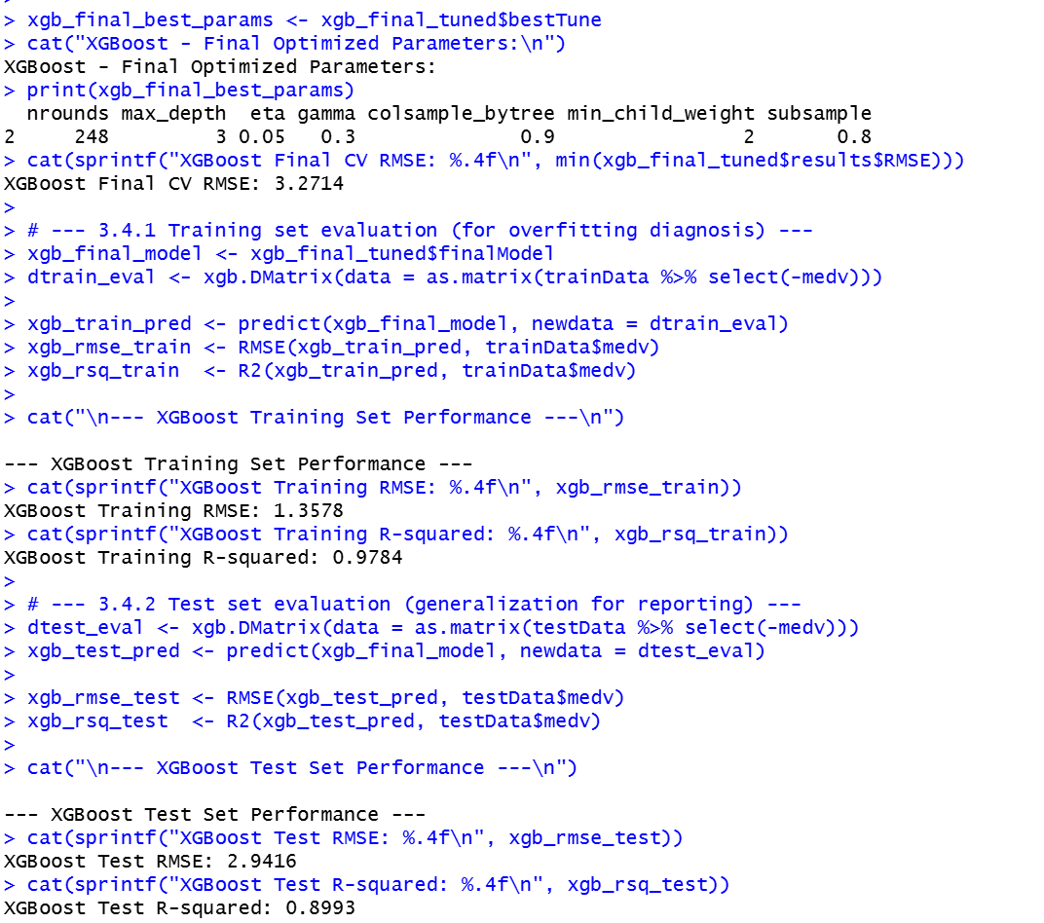
The running result:

